South Deeside Road, Banchory-Devenick, Aberdeen AB12 5YL

CANDIDATE INFORMATION FOR
THE POST OF HEAD OF CARE

Beannachar is an independent Camphill Charity and Life-Sharing Community offering a therapeutic and supportive environment for young adults with learning support needs. With a core of live-in staff, called ‘Vocational Co-Workers’, and employed staff who live off-site, our life and work is further enhanced by an annual intake of short-term volunteers from abroad. This staffing mix creates an international flavour, which is a highly valued aspect of our identity.

Beannachar is one of 11 independent Camphill communities in Scotland, 5 of which are located in Aberdeen and the shire. Camphill is a worldwide movement dedicated to building communities where everyone can find purpose and belonging. The first Camphill community was founded in Aberdeen in 1940 by a group of refugees led by Dr Karl Koenig, an Austrian paediatrician. Inspired by the ideas of Rudolf Steiner they found their purpose living and working with children with learning disabilities. At that time people with learning disabilities were excluded from education and many other dimensions of society. Camphill took the opposite approach and created communities where the individuality and potential of even profoundly challenged children was developed.
More information on Camphill can be found on the Camphill Scotland website: https://www.camphillscotland.org.uk/. More information about Beannachar can be found on our website: www.beannachar.co.uk

While Beannachar is a self-contained 28 acre estate in a semi-rural area near the River Dee, we are conveniently located only two miles from Aberdeen city centre. At the centre of our extensive wooded estate is a large 19th Century mansion house which is divided into two house communities, and there are two further purpose built houses which serve as house communities. We have a large walled garden, a working farm and numerous facilities for craft and other workshops. Originally Beannachar was a wholly land-based community. Today, the farm and garden still provide a fair proportion of the organic produce consumed by the community.

Life at Beannachar supports young people to discover and strengthen their unique talents and latent potential as they transition into adulthood. Young people need to have the chance to find themselves and find their place in the world. Those with learning support needs are no different in this respect, although finding an environment and a support network conducive to meeting their needs can be very difficult.

Beannachar strives to create that environment by providing a warm, welcoming and secure home life in a ‘House Community’, while complementing this with active and engaging working experiences and a lively and stimulating social and cultural life.

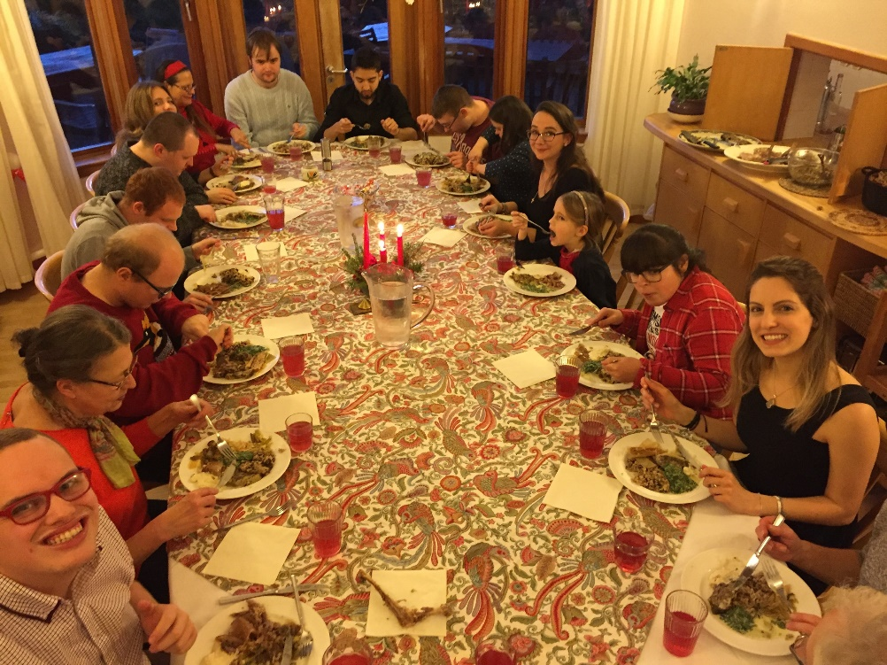

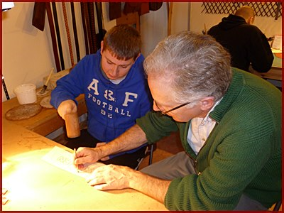
Beannachar is a ‘working community’.
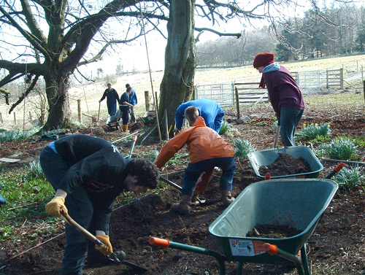

Everyone, students and staff, contribute to the meaningful work necessary for maintaining our mutual interdependence, our mutual pride in achievement, and our mutual sense of belonging to something bigger than ourselves while recognising our own, irreplaceable part in that picture.

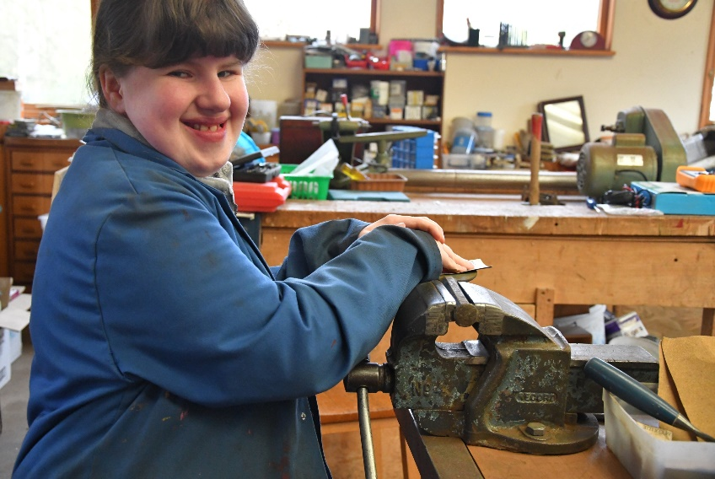
Work imparts a sense of dignity, inclusion and purpose to all who are able to access it. Enabling everyone to participate in ‘meaningful work’ is a recognised strength of our provision.

The day programme comprises a wide variety of workshop placements which run from Monday to Friday. They meet different needs and provide different ways for our students to progress through therapeutic inputs, skills development (fine and gross motor), sustained application of skills, confidence in achievement, social skills development, independence, work and team-working skills.
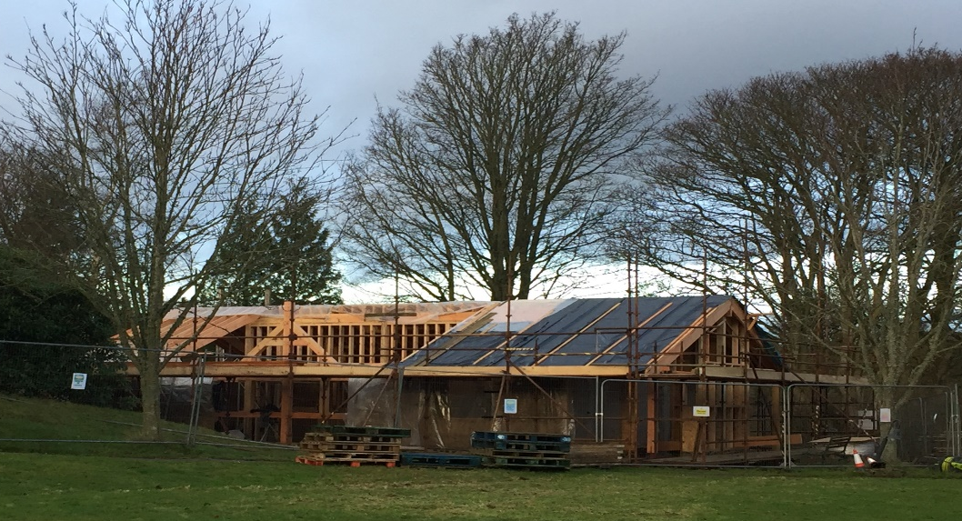

The new ‘self-build office under construction.
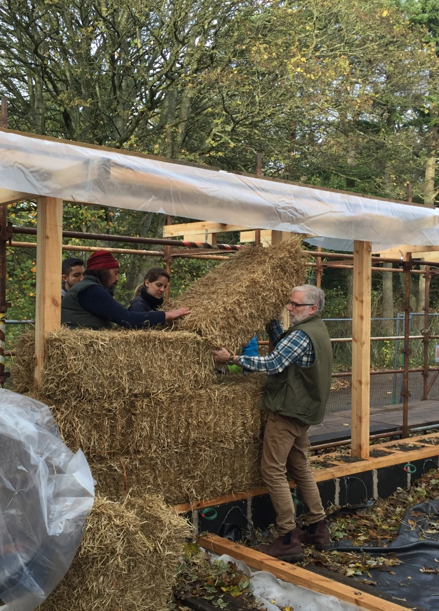

This summer will see the opening of our new Office Building. This building, which is a sustainably designed, wholly fund-raised self-build project, also heralds a new beginning for our Community. Allied to these two developments, the Board is committed to ensuring that our strategic direction gains momentum and secures Beannachar’s valuable and valued service well into the future…

Key details about the role of Head of Care
As the member of the Senior Management Team, the Head of Care will:
- Contribute to the strategic leadership of the organisation and the implementation of goals of in agreed Development Plan.
- Report to the Team Leader of the Senior Management Team (Registered Manager).
- Be responsible for the safe and effective overall management of Beannachar’s care provision.
- Maximise resident and day placement occupancies and ensure that Beannachar’s provision fully meets the needs of all of its students.
- Lead and manage a team of House Coordinators.
- Ensure that Beannachar’s Policies and Procedures are adhered to at all times.
- Ensure that Beannachar’s reputation for providing high quality care is maintained, promoted and developed.

Key information about who we are looking for
The Head of Care will have:
- A minimum of 2 years Senior Management experience.
- Excellent time management skills and the ability to manage and prioritise a broad range of responsibilities.
- A sound and up to date knowledge of the social care sector, with a particular interest/involvement in the Voluntary Sector.
- A demonstrable commitment to upholding Beannachar’s mission, values and ethos.
- Strong leadership skills with the ability to manage and motivate multi-disciplinary teams.
- Excellent verbal and written communication skills.

For further information please see the accompanying job description.

For an informal chat about this role, please do not hesitate to email us on office@beannachar.org to arrange a time to speak to a member of our Senior Management Team.

Additional information about this role
- This is a full-time, permanent position.
- Holiday entitlement is 32 days per annum inclusive of public holidays.
- Beannachar operates a Stakeholder pension scheme.
- The closing date for applications is Monday 13 May 2019.
- Application is by CV and a cover letter. Please make sure that your cover letter addresses in detail the content of the attached Job Description and Person Specification.
- Interviews for this post will be held in the first week of June 2019. Please let us know your availability when applying.

How to apply
Applications are by CV with a tailored cover letter (in separate Word documents) outlining your suitability for the role of Head of Care, with specific reference to the Person Specifications outlined in the Job Description. Send your CV and cover letter to us by email ( office@beannachar.org ) by midnight on Monday 13 May 2019.

Thank you for your interest in this role.
